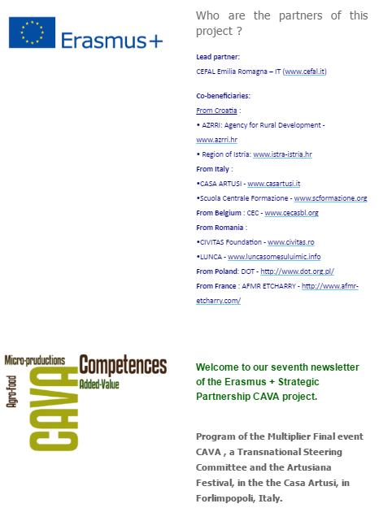



**Welcome to our Eighth Newsletter of the Erasmus+ CAVA project.    
This newsletter will present you the outputs of the seminar : “*Il gusto di apprendere: nuove competenze per la trasfomazione agroalimentare e la ristorazione”* and of the Festa Artusiana event.**

The seminar was centred on tourism and catering - agribusiness and aims at enhancing the agro-food product and typical gastronomic culture as areas of business development and job growth. It is important to highlight that the main goal of the CAVA project was to work locally: the food, the cuisine and technics are taught by local chefs and the food comes from the region where the training happened.

The subjects were agro-food, locale agriculture, entrepreneurial skills (creativity, spirit of initiative and entrepreneurship) and technical-vocational competences in the agro-food sector. The sustainability of rural economy and tourism related to the promotion of local products is a huge perspective for a balanced development of the territory as well as for the local employment possibilities.   
It aims the valorisation of typical products and local gastronomy culture as ambit for entrepreneurial development and occupational growth through promotion/qualification of production processing, integrated marketing and creation of food-supply-chains and enhancement of food market and tourism.

**The Final multiplier event took place in Forlimpopoli (Italy) at the Casa di Artusi during the festival “Festa Artusiana, Cultura a Tavola”.**During the day time learners from (different region of Italy: Puglia, Veneto, Lombardia, Fruili Venezia Giulia, Marche, Emilia Romagna), had the opportunity to learn regarding the dairy and fruit and vegetable chains in the actual kitchen of the Casa Artusi.

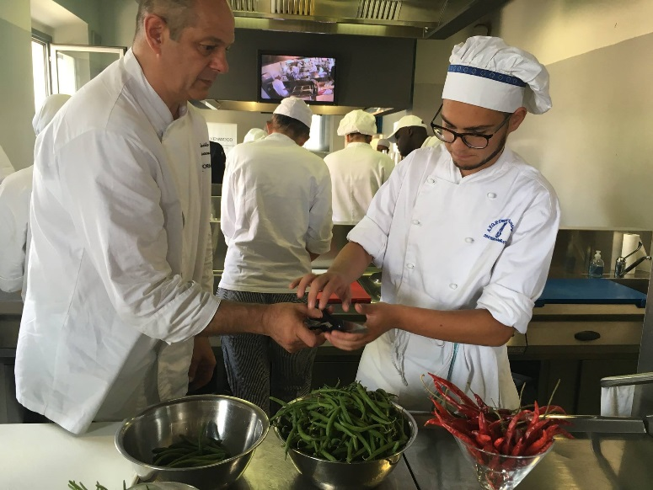

In the evening, when the festival started, when lots of pits were starting to hatch all around town, CAVA had its own, where students could present and offer tastings "eco-sustainable" products based on milk, seasonal fruits and vegetables that they actually learnt at the Casa Artusi and through the CAVA project during the evenings of 27th and 28th.

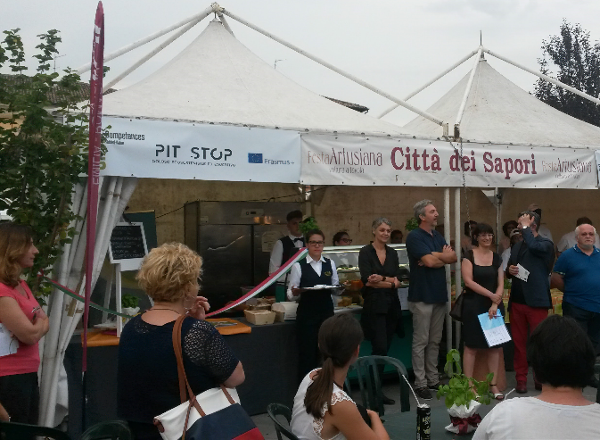…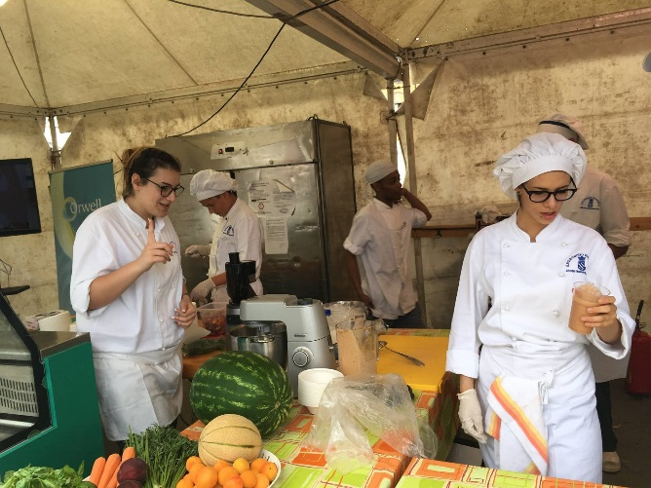

On 28th June, a seminar took place in the Casa Artusi (www.casartusi.it/en/). Among a large panel of stakeholders and subjects about local competences in agro-food, quality of food and the employment it generates.

 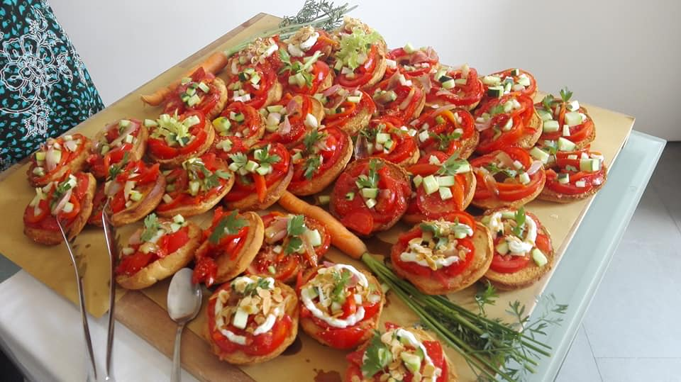

Few are worth to mention.   
Giordano Conti (Casa Artusi) emphasized the words: “celebration and good cooking” Artusi is a cultural centre of healthy food. Quality is obviously more important than quantity. It always helps to have good food to have a good time and like he said “The table is the real good place for negotiations!”

Flavio Venturi (CEFAL Emilia Romagna) chose to stress the social impact. It is true that with good and local quality food, the social inclusion grows. Students learnt a lot about the region, about how social economy and small companies work. It might have given them ideas to start their own enterprises some day! This system strengthens the agriculture world as well as the economy of the region and the tourism. These training courses brought a lot of new possibilities for the trainees as well as for the trainers.

Paolo De Castro, member of European Parliament, sent his regards to all participants by a video message. He stressed on the importance agricultural policy in Europe.

It is born after the World War 2 to assure that every family would have food on the table. It has changed through the years and now it aims to quality instead of quantity. Food should be healthy but also represent the territory where it comes from as well as it supports its economy.

Michele Vollaro and Francesco Galioto, Bologna University, emphasized the importance of a production respectful of the environment. The difficulties to produce good and healthy food quickly brought new technologies. It’s now, one of the purposes of the Agricultural policy.

Those new technologies opened a whole new panel of possibilities for inclusion and integration in short supplies chains.

It’s important to also mention the importance of the link between tourism and local (rural) economy.

Giacomo Sarti and Laura Minieri from Cefal ER presented the CAVA project explained above. Following her explications Anca Marcu, (Civitas / Agricultural Coop. Lunca Somes Mic - Romania) DOT (Tourism Board of Lower Silesia - Poland) and Marco Dalla Rosa (Agro-Food CIRI Bologna University Cesena Campus - Italy) took the time to explain how well the project has been working so well for them.

During the event the following experiences were shared:

The “Autoconservazione”project: it involves the construction of a network between Veneto Agricoltura, Agricultural businesses, the “Keeper Farmers”, and enterprises to ensure sustainable profitability for activities related to biodiversity and organic productions.

Small local productions: the project has defined a process for the hygiene safety and the sale of agricultural products in small amounts.

Francesco Pasolini's from La Fraternità Social Cooperative presented the story of an economic start-up founded from the poorest thanks to different projects: the protected label "La Pietra Scartata", born in San Clemente, in the province of Rimini, by his parents Pino and Daniela, transforms and commercializes organic food products,” respecting the nature as God created it” under the label " La Madre Terra ". Having been on the market for almost thirty years now, it is a brand that has now been established that in addition to identifying high quality organic products, it also contains the commitment of those who, with different abilities, have regained their dignity through work.

Pamela Scardovi, member of Agricultural Society Baroncini Mirco e Fabio, explained her project “The Good Milk”.  
The Good Milk is a brand which produces milk and other dairy products. The quality comes from the controlled and selected dairy cows of the [Baroncini Mirco e Fabio Dairy Farm in San Bernardino di Lugo](http://www.ilbuonlatte.it/en/p5/our-story/). A short reliable chain of production as well as the welfare of the animals makes the production authentic and healthy.

Milena Garavini (Region of Emilia Romagna, Italy) and Lorena Miletić Region of Istria – Croatia told us a little bit more about how “short circuit” are important: local agriculture, local food and local enterprises. All those sectors (the whole agro-food sector actually) is very important for the social economy of the region. It raises money but mostly it raises employment in the whole sector. Working on a local level is the best way to keep the economy working.

On the side from this interesting seminar, a visit of a local farm “Azienda Agricola Bertozzi” was offered.   
For several years now, this farm has been working on a local level only! From the culture of cereals to the feeding of their animals (caws, lamps, horses…), they do it all on a local level, so they can be certain of the quality of the products.   
The quality of the animal food will make the quality of the meat, so they are very picky and serious about it.

They also offer “hippotherapy” with horses (with disable people) and courses of horse-riding, especially during the summer when children can come to their “summer camps”.

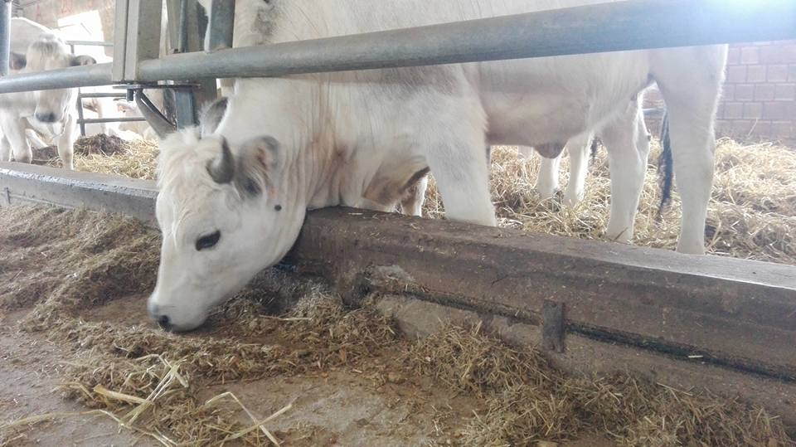

This was the final event of CAVA project, it started in September 2014 and it’ll be officially over in August 2017.

The one sentence to remember from this newsletter is: “Sharing food and culture is inescapable, because it brings us together, it brings European Union together through cuisine! “