6th Newsletter of CAVA project.
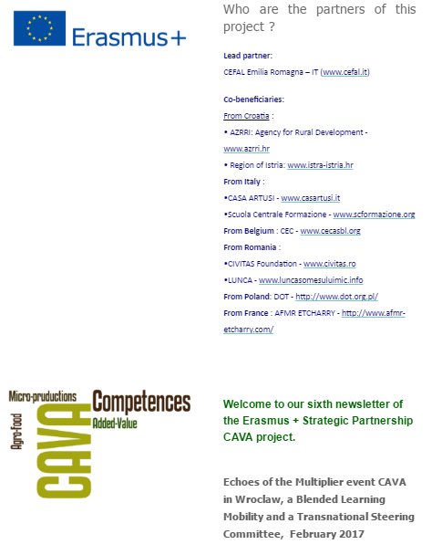
The Blended Learning Mobility was held in Wroclaw hosted by DOT - Wroclaw's Lower Silesian Tourist Organisation (www.dot.org.pl) during February (20th – 24th February).
Who Came?
Thirteen learners from Poland, Italy, Croatia and Romania were attending the Blended Learning Mobility in Wroclaw.
The learners are young adults employed in development of entrepreneurial activities in agro-food sector, young people (15-20 year-old) in initial vocational training in catering or agro-food sectors.
Moreover, six accompanying persons, chefs and trainers from Italy, Croatia and Romania, were supporting the learners during all the activities.
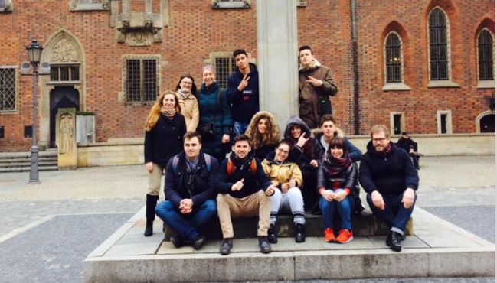
During this blended mobility, the learners had the opportunities to try, taste and visit the world of gastronomy in Wroclaw.
They started by attending a cheese laboratory in order to increase their competences in dairy chain. First, they started by getting to know the product and all the steps to be able to make haloumi cheese and other products derived from soya such as soya milk or tofu.
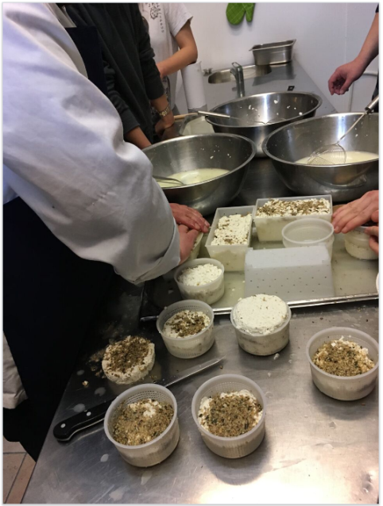
The very next day they learnt about meat processing, from theory to actually making traditional Polish products such as parboiling sausages or smoking sausages.
The third important lesson about food in Wroclaw was the vegetal processing; in Poland it is very common to preserve vegetables into jars in sour-sweet. They learnt the process all the way from the beginning.
Besides the cooking lessons, the learners had the chance to visit a local Brewery “Browar Stu Mostòw”, where they met with the manager who explained the marketing for local products.
The participants got to know the history of local brewer and its strategy which is strongly emphasizing on high quality and regional origins. The aim of the visit was to show good practice in creating small, family entrepreneurships.
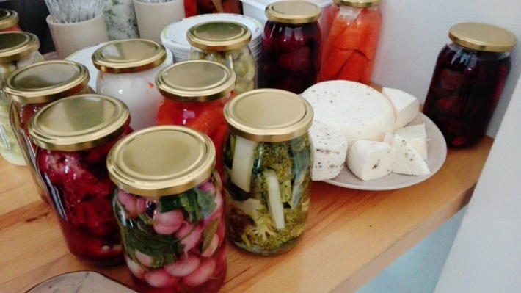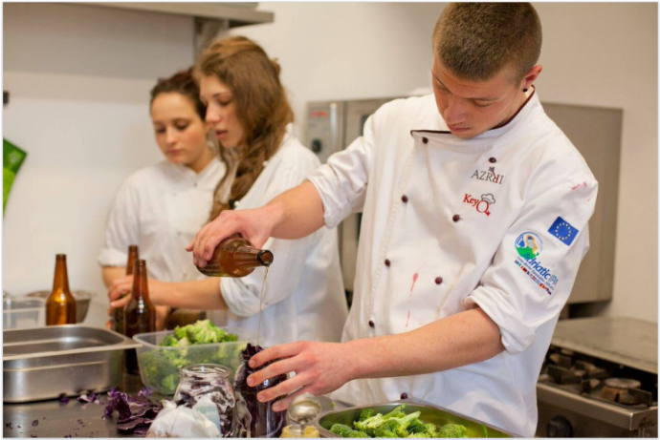
They also had a meeting with local authority responsible for Dolnośląskie heritage Project: Mr. Ryszard Czerwiński, the leader of Rural Areas Development department, Marshall Office of Lower Silesia Region. He presented the international project promoting the use of culinary heritage of regions. Mr.Czerwiński described certification procedure for facilities and granting them with the sign ‘Culinary heritage’.
On the same day, they visited the Hala Targowa, a historical market where local and international food from all over the world, for many years have had the opportunity to present and sell their own products.
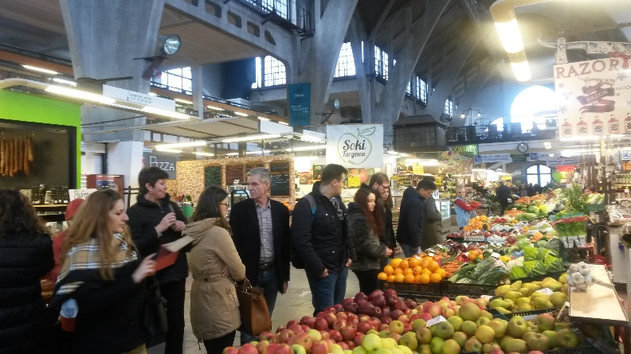
Later, they went to “Bazar Smakosza”, a local food market with fresh products coming from local producers. They had the chance to talk with merchants whom presented a slow food culinary workshop.
On Friday, the last day, the learners had the opportunity to show what they had learnt during a cooking contest. Supervised by chefs, students in mixed nationalities groups prepared dishes based on gained knowledge. Those dishes were presented during a small conference about CAVA project happening at the Food Think Tank (www.foodthinktank.pl ) in Wroclaw.
Rajmund Papiernik, Director of Wroclaw's Lower Silesian Tourist Organisation introduced the project and the Mobility, followed by Professor Marco Dalla Rosa, Director of CIRI Agrofood University of Bologna – Campus of Cesena who presented the role of regional products in economy and Giacomo Sarti, Project Coordinator of the lead partner Cefal Emilia Romagna), who presented the CAVA Project.
While students were learning about food and local market, a Transnational Steering committee was taking place. Partners (from Belgium – CEC, Italy –CEFAL ER, Casa Artusi and Scuola Centrale Formazione, Poland – DOT, Romania- CIVITAS and Coop. Lunca and Croatia – AZRRI and Istrian Region) could discuss the progress of the project and make decisions about the testing phase and the upcoming events.

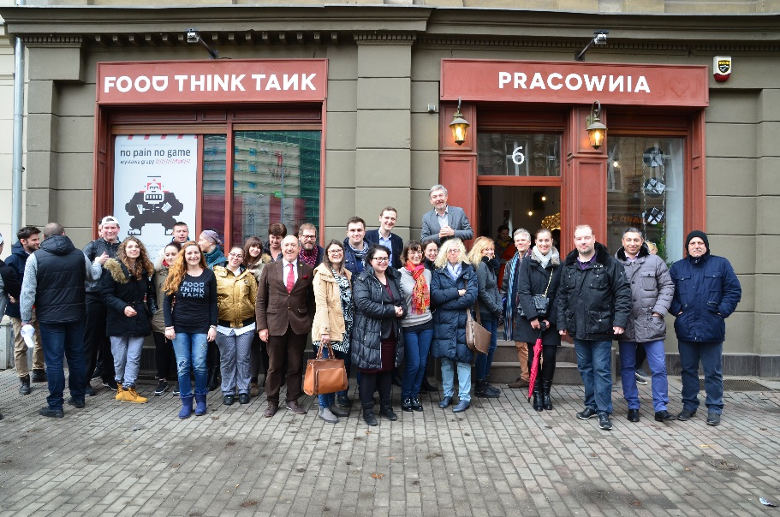

Next events:
Italy: 26-28th of June 2017 Steering Committee and Final International Multiplier Event in Forlimpopoli during Artusiana Festival (http://www.casartusi.it/en/)

